**Pages 3**

**Immediate actions 3**

**Flow Chart 4**

**Designs 5**

1 Home page 5

2 History 5

3 Graph View 5

4 List View 5

5 Inhabitants List 5

6 Edit Inhabitants List 5

7 Settings 6

8 Change date/time 6

9 Change Feeding Routine 6

10 Meal Selection 6

11 Add New Meal 6

12 Edit Meal 6

13 Delete Confirmation 7

14 Change Cleaning Routine 7

15 Change Parameter Preferences 7

16 Select Parameter 7

17 Set Min/Max Values 7

18 Save warning 7

19 New Test Type Selection 8

20 Test Instructions 8

21 Results Loading 8

22 Test Results 8

23 Too High 8

24 Too Low 8

25 Feed your fish 9

26 Clean your tank 9

27 Test your tank 9

28 Change testing routine 9

29 Fed Fish 9

30 Cleaned Tank 9

31 Manual Test Input 10

**Improvements to be Made 11**

**Testing the UI 11**

Tasks 11

# 

# Pages

* Home
* Settings
* Change date/time
* Change feeding routine
* Change cleaning routine
* Change parameter preferences (all parameter types)
* New test instructions
* Test results
* Danger too high
* Danger too low
* Parameter test history (all parameter types)
* Graph of history
* List of history
* Inhabitants list
* Edit inhabitants list
* Feed your fish!
* Clean your tank!
* Export data

# Immediate actions

* Fed fish
  + Updates history of fish feeding
* Cleaned tank
  + Updates history of cleaning
  + Updates "next cleaning" timer

# Flow Chart

# 

# Designs

## 1 Home page

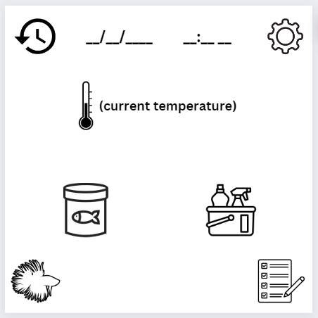

## 2 History

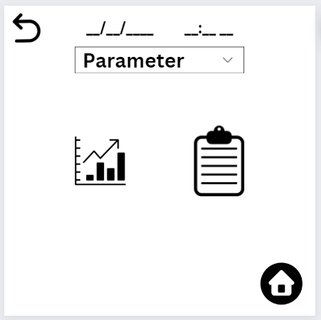

## 3 Graph View

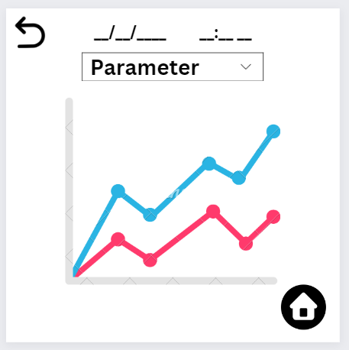

## 4 List View

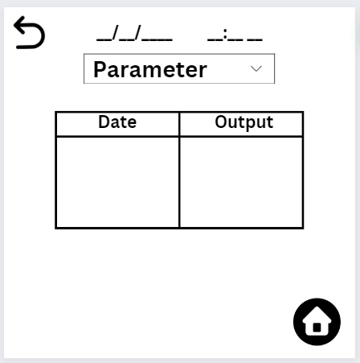

## 5 Inhabitants List

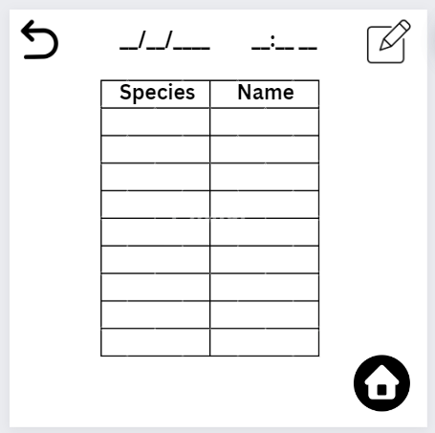

## 6 Edit Inhabitants List

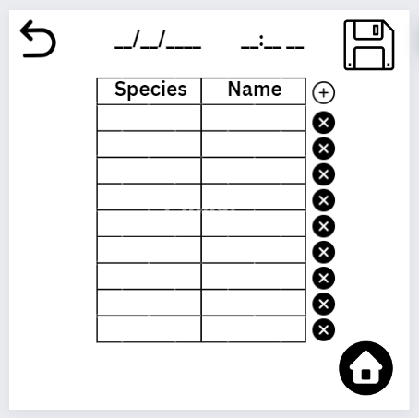

## 7 Settings

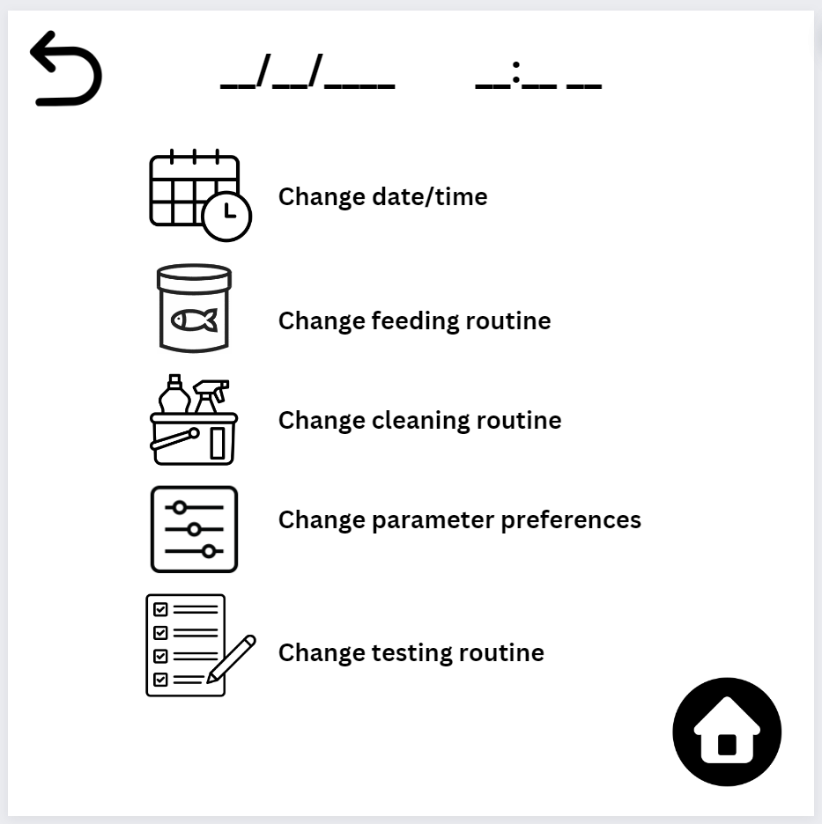

## 8 Change date/time

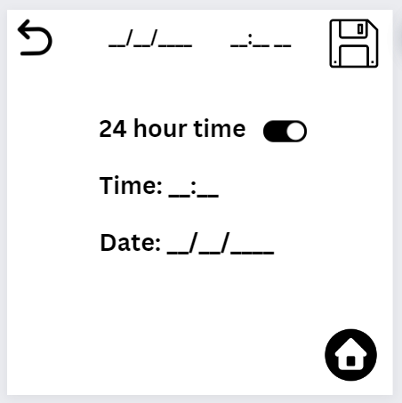

## 9 Change Feeding Routine

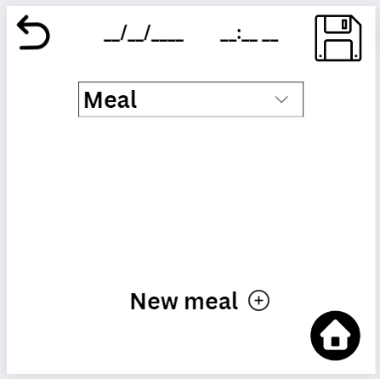

## 10 Meal Selection

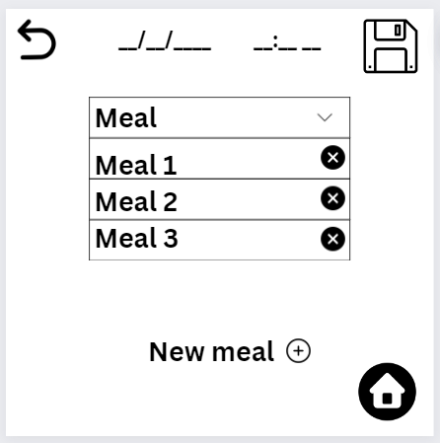

## 11 Add New Meal

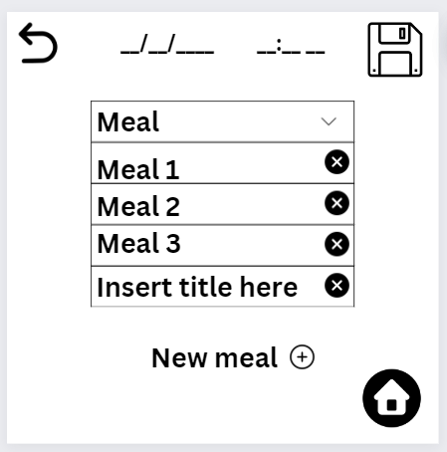

## 12 Edit Meal

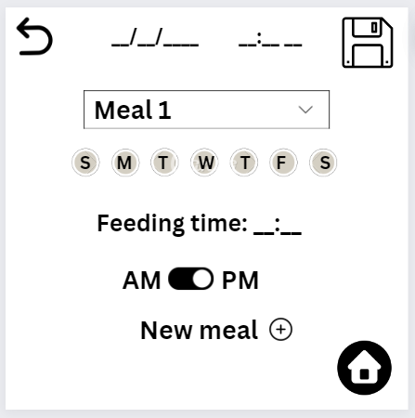

## 13 Delete Confirmation

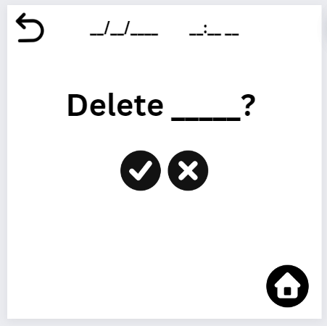

## 14 Change Cleaning Routine

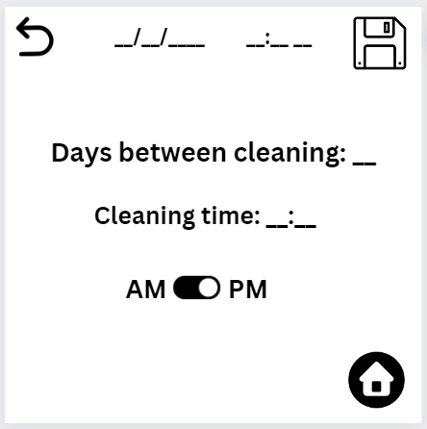

## 15 Change Parameter Preferences

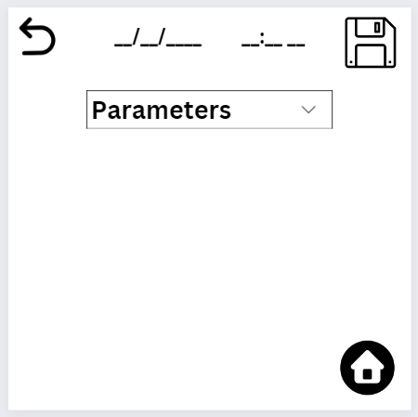

## 16 Select Parameter

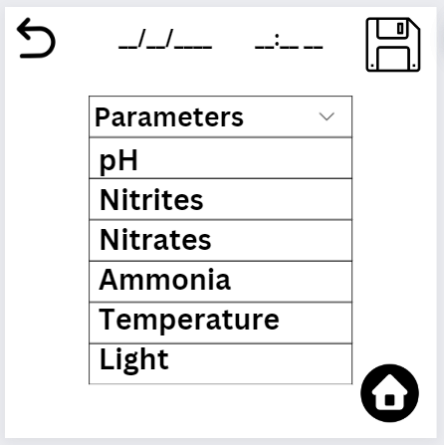

## 17 Set Min/Max Values

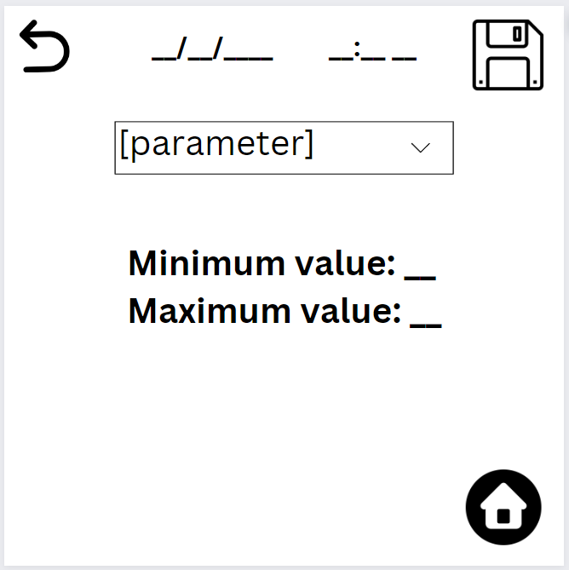

## 18 Save warning

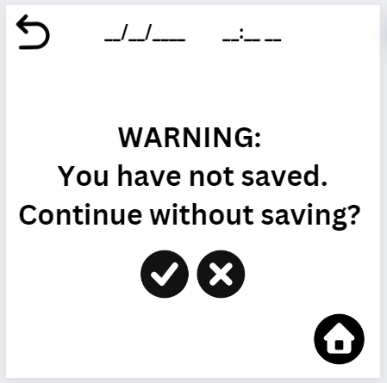

## 19 New Test Type Selection

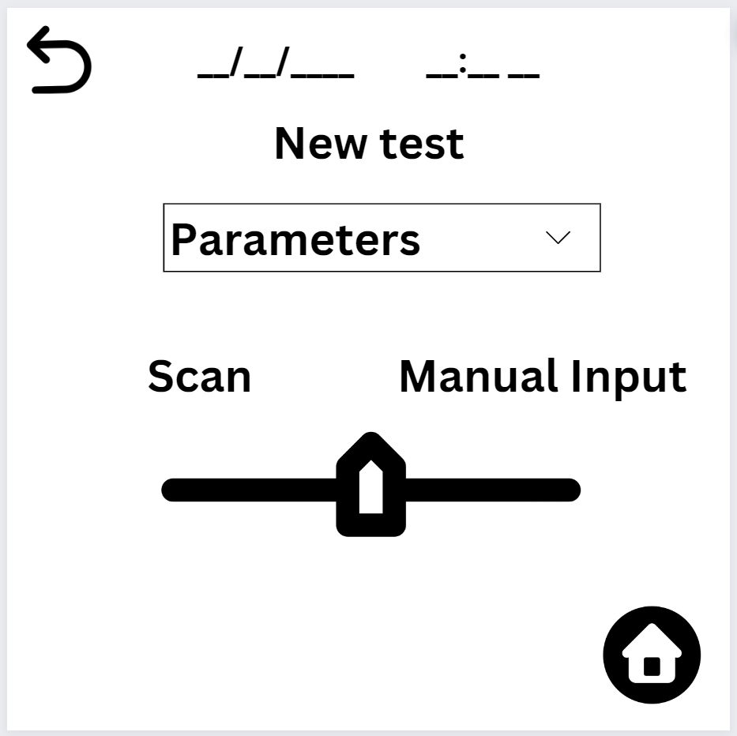

## 20 Test Instructions

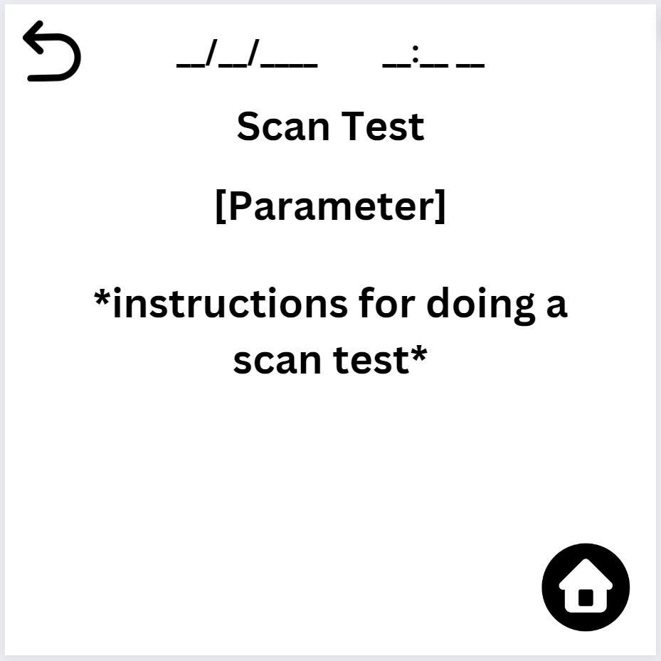

## 21 Results Loading

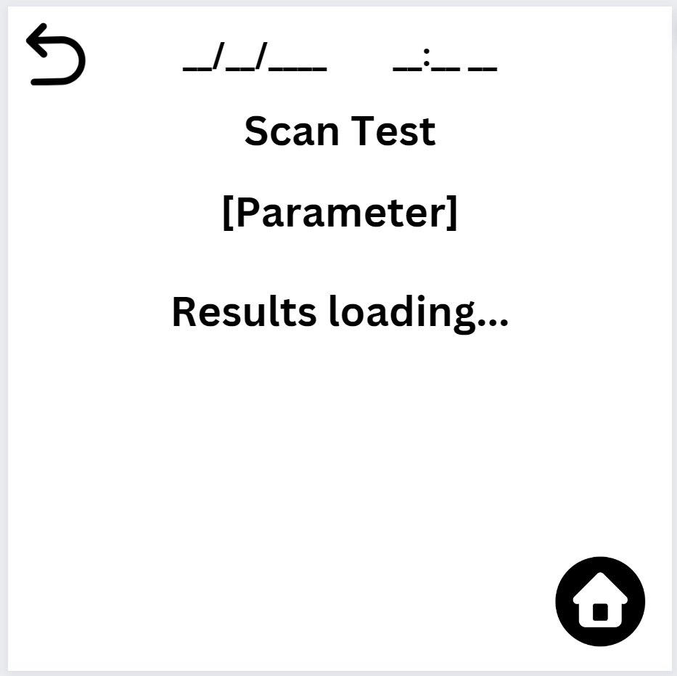

## 22 Test Results

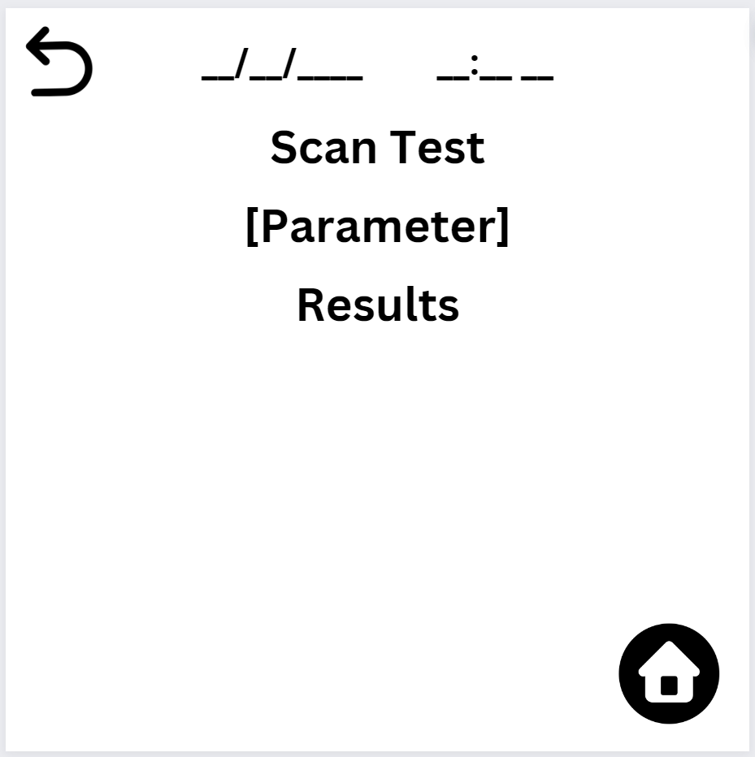

## 23 Too High

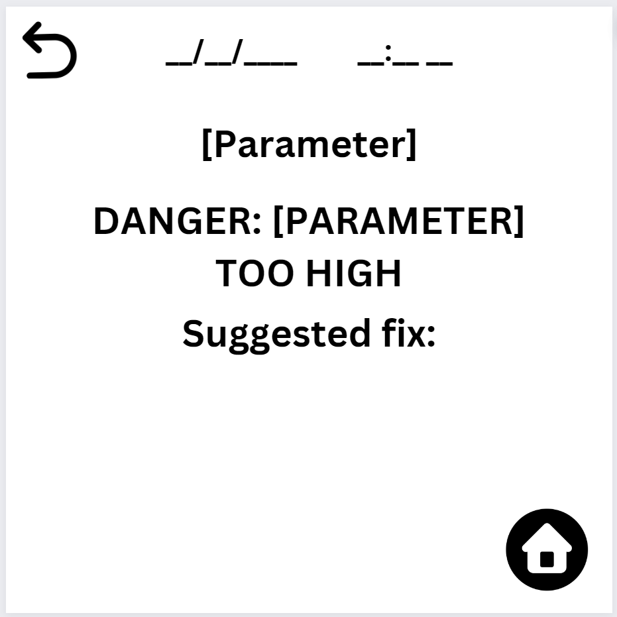

## 24 Too Low

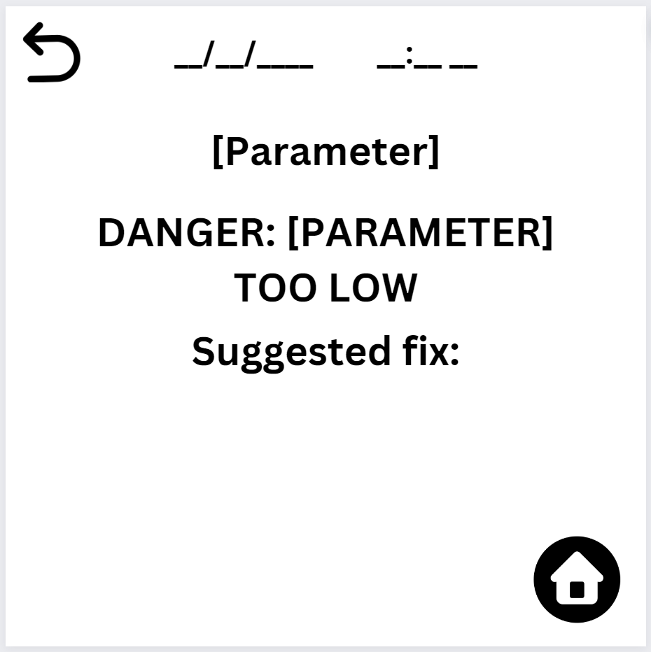

## 25 Feed your fish

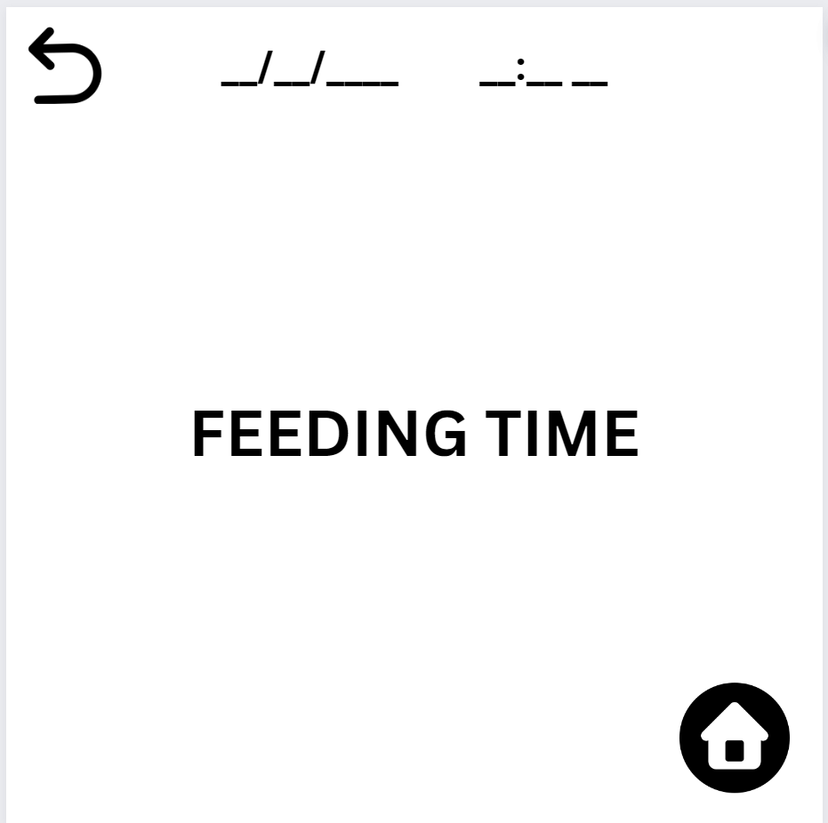

## 26 Clean your tank

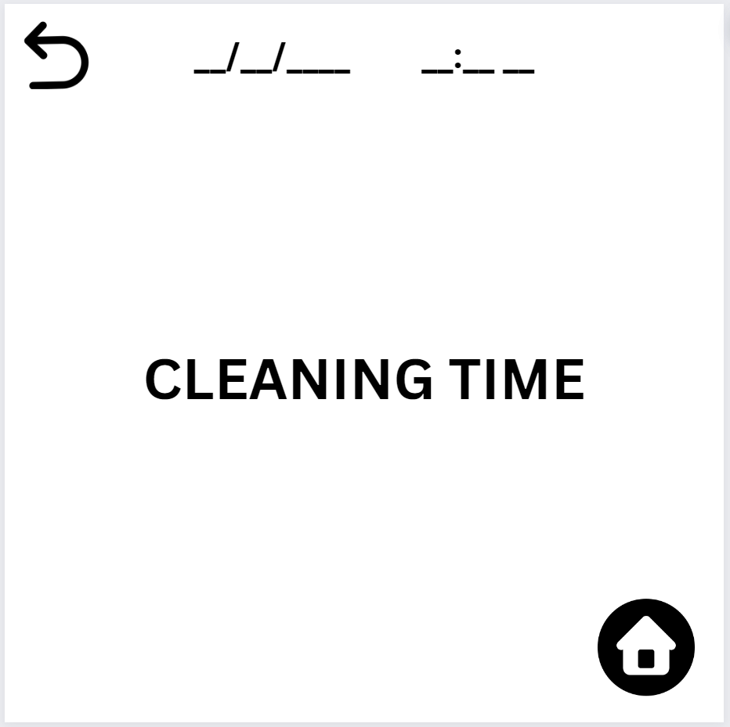

## 27 Test your tank

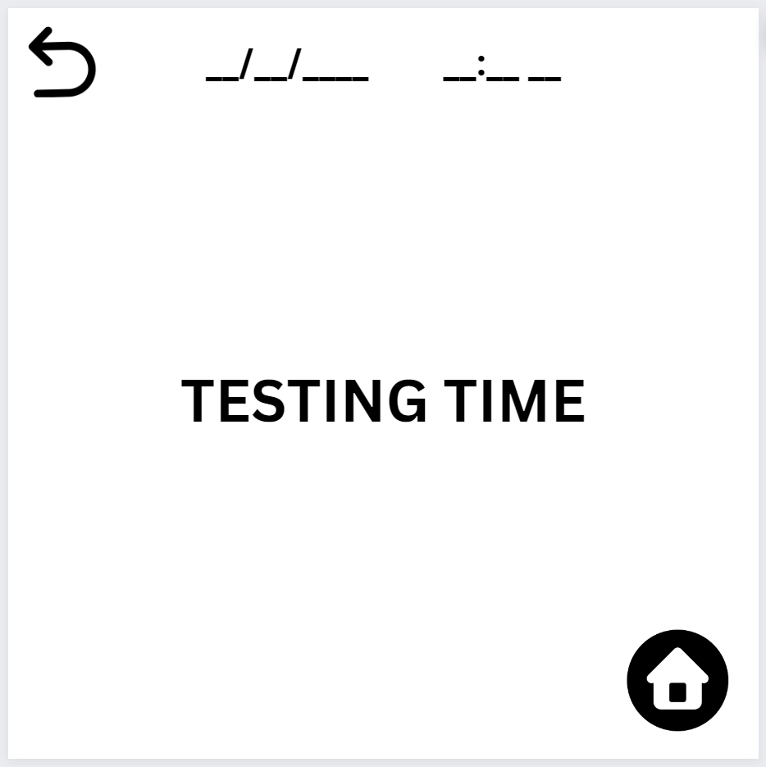

## 28 Change testing routine

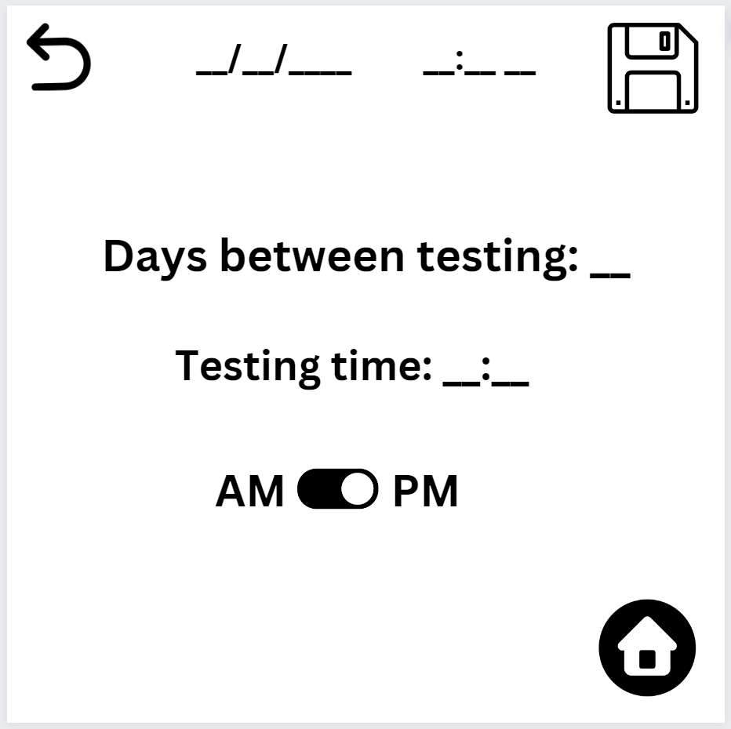

## 29 Fed Fish

## 

## 30 Cleaned Tank

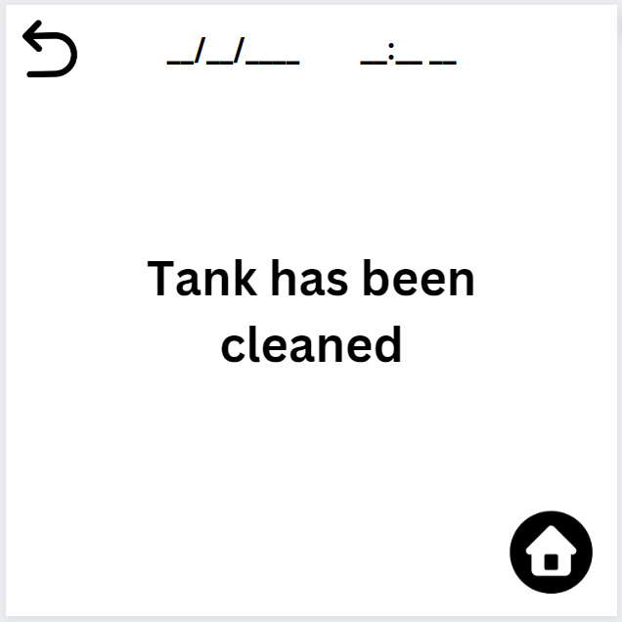

## 31 Manual Test Input

## 

## 32 New Fish Input

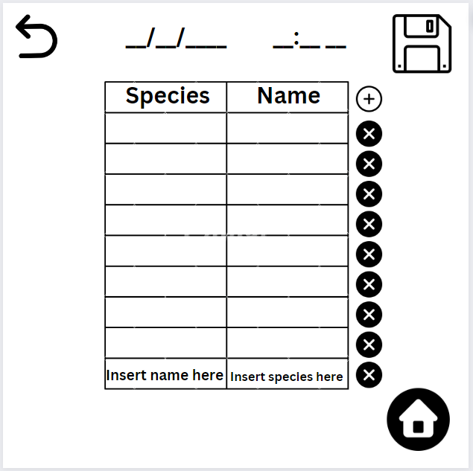

# 

# Improvements to be Made

* Add an option to export data
  + Probably in history section

# Testing the UI

## Tasks

* Add an inhabitant
* Change the date
* See pH history in graph form
* Input a new test result manually
* Add a new meal
* Delete a meal
* Run a new test with the scanner
* The testing alert has gone off, enter test results manually